This document is merely to point out the differences in confessional count numbers between my findings and the official numbers posted on Survivor Sucks. The guidelines I use can be found [here](https://docs.google.com/document/d/18ofsPiVWxSejzSjEGlU8KEx4Og2ddEJScCV23RsCPIA/edit?usp=sharing).

**Survivor Sucks Season 21 Counts** ([link](https://goo.gl/photos/rU7o6L7SUJBiBVEV6))

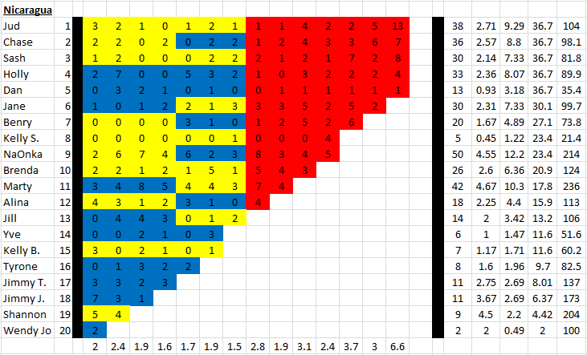

**My Season 21 Counts** ([link](https://goo.gl/photos/pW9XbLM97LfgpdV27))

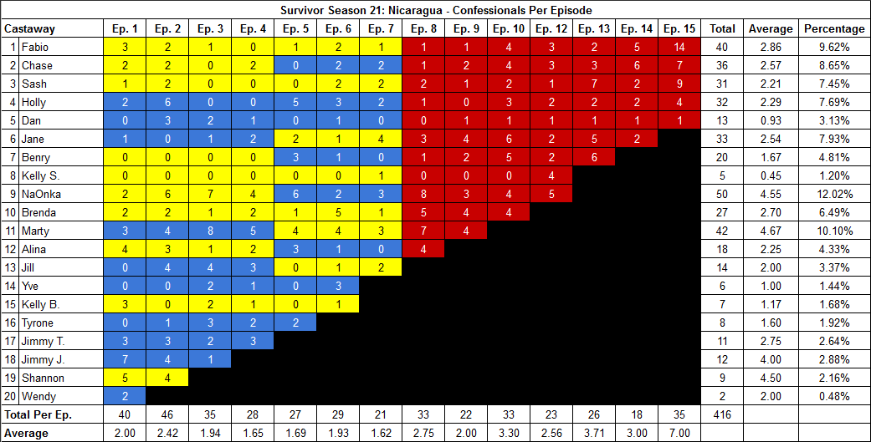

[Survivor Sucks Season 21 thread](http://survivorsucks.com/topic/74229).

**Differences**

[Episode 02](https://docs.google.com/document/d/1CNuFZ8FjyussytMSNVMWJBCOHSHg-I0EiZwOS7m-m0g/edit?usp=sharing)

* **Holly: 6 (-1)** Confessional #13 has on-the-fly elements, which when included, decrease Holly’s count to 6. If not included, she would remain at the established 7.
  + Confessional breakdown:
    - [**start of confessional**] (09:24 →) I don't think they realized that I was watching them, and Dan, who is making fun of me, that gets under my skin. So I think the best way for me to handle the situation with Dan is to try to find a way to release my anger. (← 09:39)
    - [**on-the-fly segment starts**] (09:41 →) The New York City boy, Danny, he doesn't like sand on him. So let's just fill his shoes up, and then… put them somewhere. Make sure they're tied. Take them over here. (← 09:53) [**end of on-the-fly segment**]
    - [**interview resumes**] (09:54 →) I'm not going to sit back anymore and let them rub things in my face. I've been too nice up to this point. But the game has just begun.
      * As shown, the gap compromising the on-the-fly element goes from 09:39 to 09:54 which constitutes a 15s gap. If this element were not included in the confessional, then at the start of time mark 09:54, Holly would have an additional confessional, bringing her count to the established 7. Since I included the on-the-fly segment, I got a count of 6 because the gap is 2s and 1s, respectively.
* **Jimmy J: 4 (+1)** Confessional #24 has a 10s gap.

[Episode 07](https://docs.google.com/document/d/1WVM-4n57Z2xe9pFvDZ_raf82sw7RJK-mSfrcLLDnHyA/edit?usp=sharing)

* **Jane: 4 (+1)** Confessional #10 has a 12s gap.

[Episode 09](https://docs.google.com/document/d/1hzrgfHlvnqs3NV1pmBQ-iFGfWnU6crOzKRn2wxJ06AY/edit?usp=sharing)

* **Jane: 4 (+1)** Confessional #7 has a 14s gap.

[Episode 10](https://docs.google.com/document/d/1iZjSE3XbOClXHPPchUquyJAdEs-vZQhDBz9y4s5JfWk/edit?usp=sharing)

* **Jane: 6 (+1)** Confessional #13 ia an on-the-fly confessional where Jane talks directly to the camera just before she slides down the volcano.
* **Brenda:** **4 (+1)** In this episode, I counted a total of 4 confessionals for Brenda instead of the established 3. There are no significant time gaps.

[Episode 12](https://docs.google.com/document/d/1X_qgS37Slb8ReVgX7WZeU0aExDFOFQm2oxisVT-MpGU/edit?usp=sharing)

* **Fabio: 3 (+1)** In this episode, I counted a total of 3 confessionals for Fabio instead of the established 2. There are no significant time gaps.

[Episode 15](https://docs.google.com/document/d/1w1CDoGUriqBaAxl6hom-inYg8zPmOLz3CUkNeD1kNgQ/edit?usp=sharing)

* **Fabio: 14 (+1)** In this episode, I counted a total of 14 confessionals for Fabio instead of the established 13. There are no significant time gaps.
* **Sash: 9 (+1)** Confessional #3 has an 11s gap.

**No Change**

* [Episode 01](https://docs.google.com/document/d/1i2X18sYdCsZYUecF8M3Uowz90SOTfv_G2RBcMZOe8RU/edit?usp=sharing) **Note:** Confessional #32/33 is a dual confessional between Alina and Kelly B.
* [Episode 03](https://docs.google.com/document/d/1hhwPy2N-G4lMgb-eEtPaLgTf8MwVYuCy1KzCusj-aeE/edit?usp=sharing)
* [Episode 04](https://docs.google.com/document/d/1Nad3gLzMoOPweqW2_A0yeLcSJpHDAiVusnk4SqmiadI/edit?usp=sharing) **Note:** Confessional #22 is an on-the-fly Jill confessional where she looks directly at the camera and narrates what she’s doing and Jimmy T. and Tyrone can be seen in the background walking. Jill’s chyron is visible on-screen during this.
* [Episode 05](https://docs.google.com/document/d/1EUk3Q5iNtjK6alDovscmV62XZz1stXXrm2Whj7D93wg/edit?usp=sharing)
* [Episode 06](https://docs.google.com/document/d/1MK3WyzNYszAjalpwg9geI5p_gRlOT5Mrrb1kEekRXh8/edit?usp=sharing)
* [Episode 08](https://docs.google.com/document/d/1AT1nHkVsJyfSyeJxw8zs0D5hZv2O7JLmQ3ukZZ-3E_Q/edit?usp=sharing) **Note:** Confessional #18 is a NaOnka on-the-fly confessional where she narrates while she hides the flour. It was counted originally.
* [Episode 13](https://docs.google.com/document/d/1D17I0xtEb3r7HkXn0gg3Y-6eBWgiWTVuuMfCMbzWhMY/edit?usp=sharing)
* [Episode 14](https://docs.google.com/document/d/19rUiMJ3mtd1pqd6CLhWkoEMtAmOjFC1Y2HfYitI1V1w/edit?usp=sharing)

|  |  |  |
| --- | --- | --- |
| **Castaway** | **Count** | **Change** |
| Fabio | 40 | +2 |
| Sash | 31 | +1 |
| Holly | 32 | -1 |
| Jane | 33 | +3 |
| Brenda | 27 | +1 |
| Jimmy J. | 12 | +1 |
| **Total** | **416** | **+7** |

**Revised Sucks Counts** ([link](https://goo.gl/photos/d1Qg9GKzRqKwxfwt7))

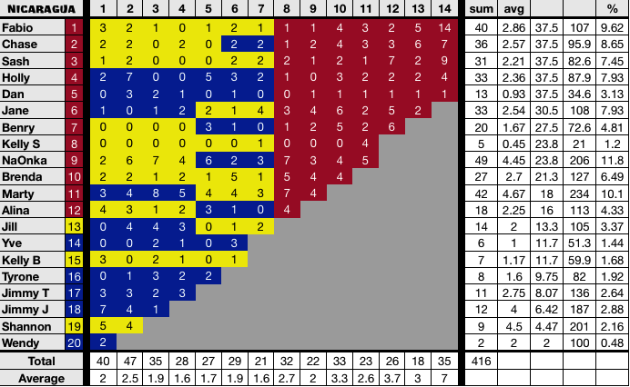

**Differences**

Most changes were accepted except for:

* **Holly:** Confessional #13 on Ep2 which had an on-the-fly segment and brought her count down to 6. She currently remains with 7 for that episode (+1).
* **NaOnka:** Confessional #18 on Ep8 is an on-the-fly confessional which brought her count to 8 and was not counted on Sucks. She currently remains at 7 for that episode (-1).